A decision tree is a [decision support](https://en.wikipedia.org/wiki/Decision_support_system) tool that uses a tree-like [graph](https://en.wikipedia.org/wiki/Diagram) or [model](https://en.wikipedia.org/wiki/Causal_model) of decisions and their possible consequences, including [chance](https://en.wikipedia.org/wiki/Probability) event outcomes, resource costs, and [utility](https://en.wikipedia.org/wiki/Utility). It is one way to display an [algorithm](https://en.wikipedia.org/wiki/Algorithm) that only contains conditional control statements.

Decision trees are commonly used in [operations research](https://en.wikipedia.org/wiki/Operations_research), specifically in [decision analysis](https://en.wikipedia.org/wiki/Decision_analysis), to help identify a strategy most likely to reach a [goal](https://en.wikipedia.org/wiki/Goal), but are also a popular tool in [machine learning](https://en.wikipedia.org/wiki/Decision_tree_learning).

The CART algorithm is structured as a sequence of questions, the answers to which determine what the next question, if any should be.  The result of these questions is a tree like structure where the ends are terminal nodes at which point there are no more questions.  A simple example of a decision tree is as follows

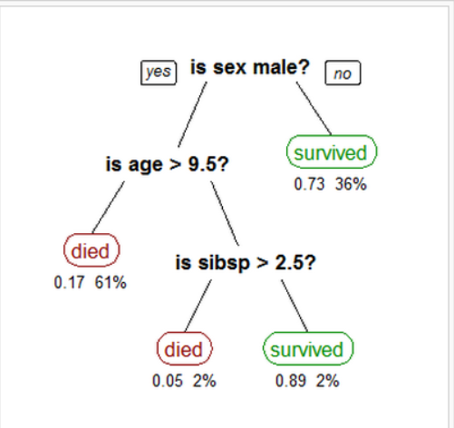

The main elements of CART (and any decision tree algorithm) are:

1.Rules for splitting data at a node based on the value of one variable;

2.Stopping rules for deciding when a branch is terminal and can be split no more; and

3.Finally, a prediction for the target variable in each terminal node.

In this project, I use a decision tree to train my cancer data. I set the samples have equal weight and use the best splitter instead of random in the algorithm. I set the maximum depth of the tree to 1 and the minimum number of samples required to split an internal node to 2. After running a 10 fold cross validation. I get a final accuracy of 92%. Although it is not the best classifier I have ever used, it is still a reasonable machine learning alghorithm to solve this problem.